**ASSIGNMENT -2**

**Pharma Sales Dashboard**

|  |  |
| --- | --- |
| Batch number | 11 |
| Student Name | MANJULA S |
| Student Roll Number | 921319104110 |

**Description:-**

Sales of Pharmaceutical products, which may include medicines, surgical devices, consumables of any form, machines, and equipment used in surgeries are called Pharma Sales. The target audience is doctors of any kind, chemists, and/or purchase in charge in hospitals or pharmacies.

Pharmaceutical sale is very different from regular sales of any kind right from the product to the customer to the process of selling. Of all the sales, Pharmaceutical sales are considered to be one of the most lucrative and most challenging jobs requiring a lot of learning on the salesperson’s part.

Like every sale, there is a buyer and a seller. In this case, the buyer depends on the product of the manufacturer. We will consider all of the buyer kinds.

1. A buyer for medicines of any kind – Chemist, Distributor, Hospital Pharmacies

2. A buyer for medical devices, instruments, implants – Doctor, purchase officer

**Challenge:** Upload the dataset to Cognos analytics, prepare the data,explore and create Interactive Dashboard.

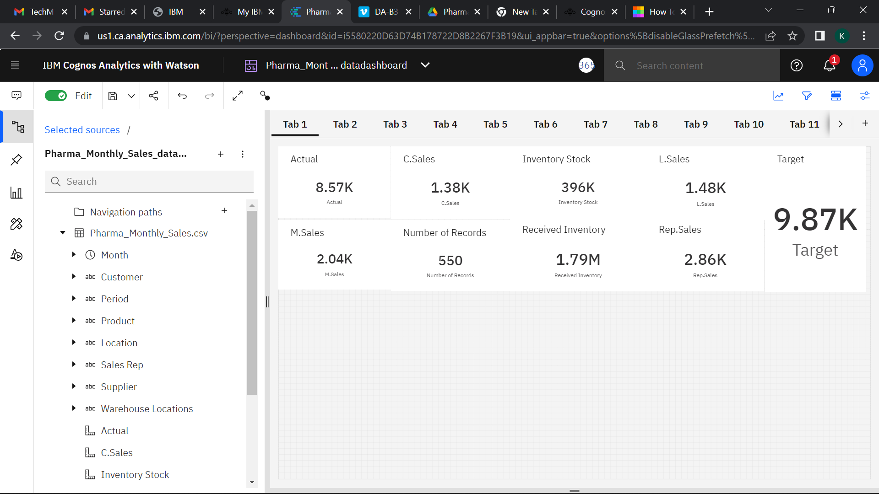

**SALES BY CUSTOMER**

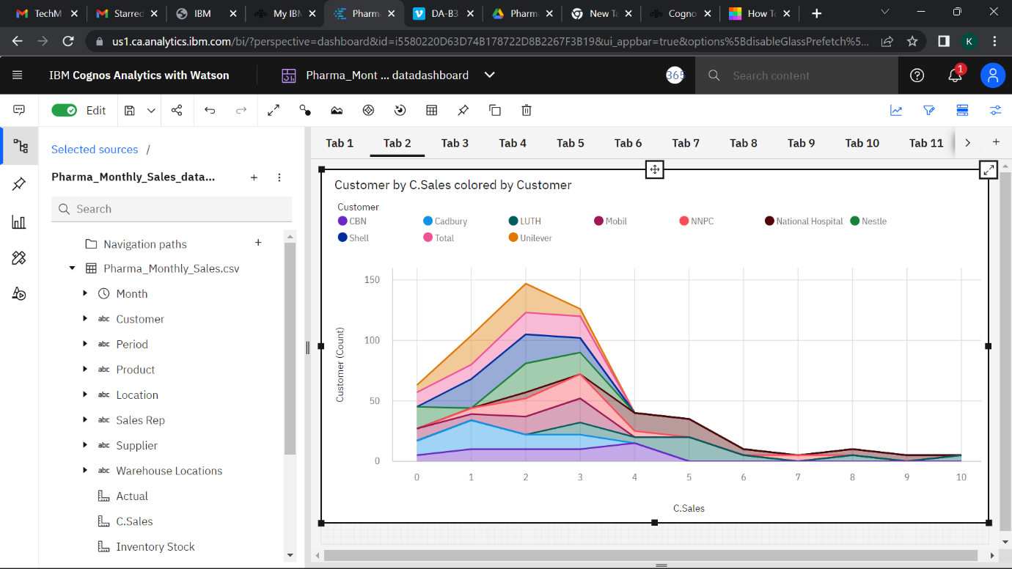

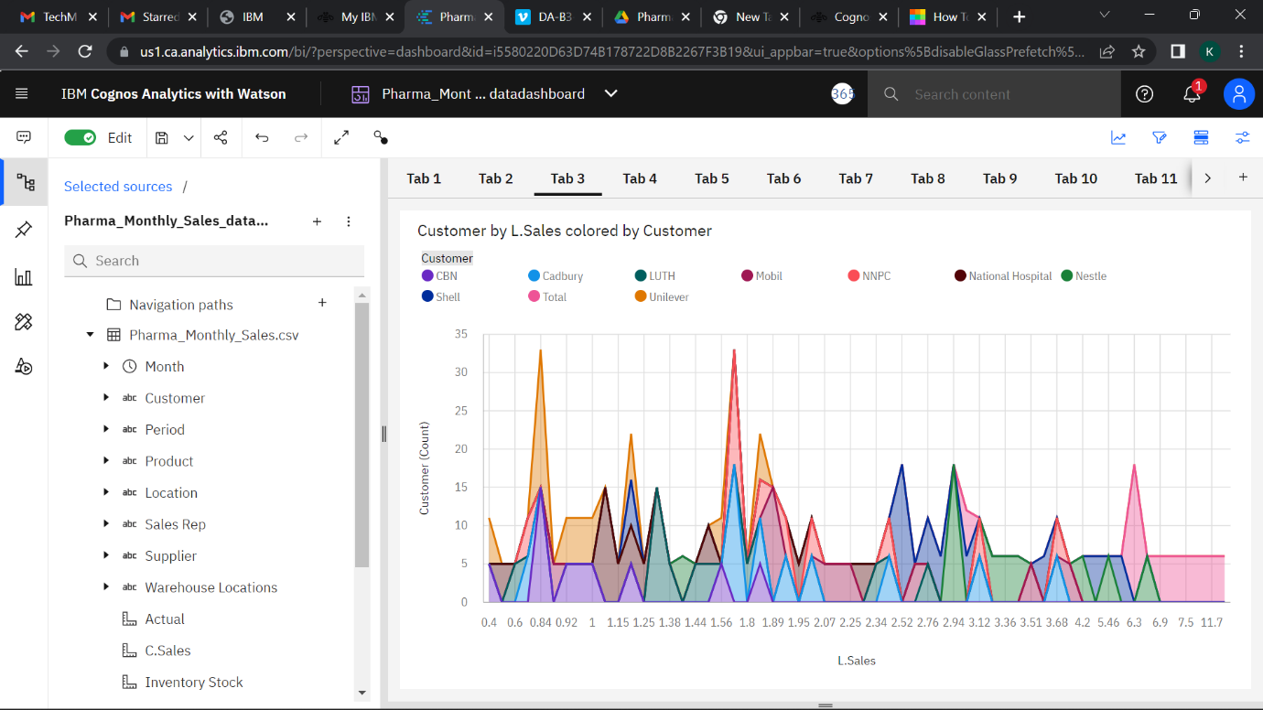

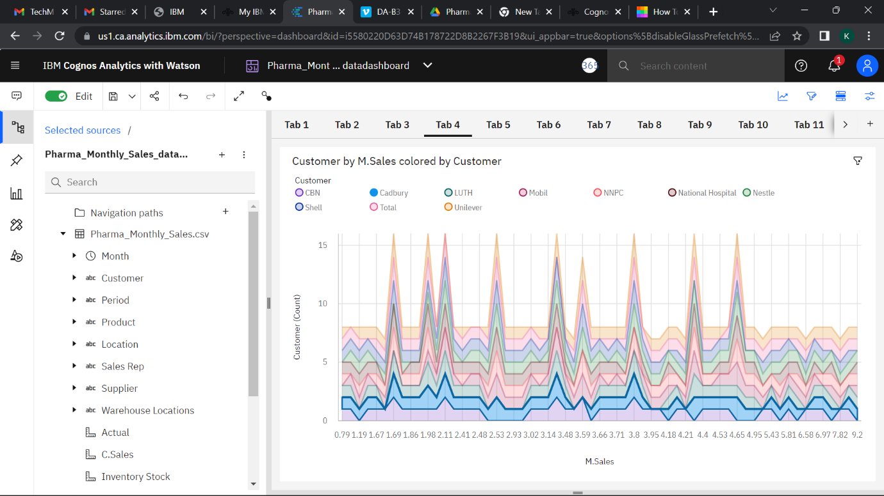

**SALES BY LOCATION**

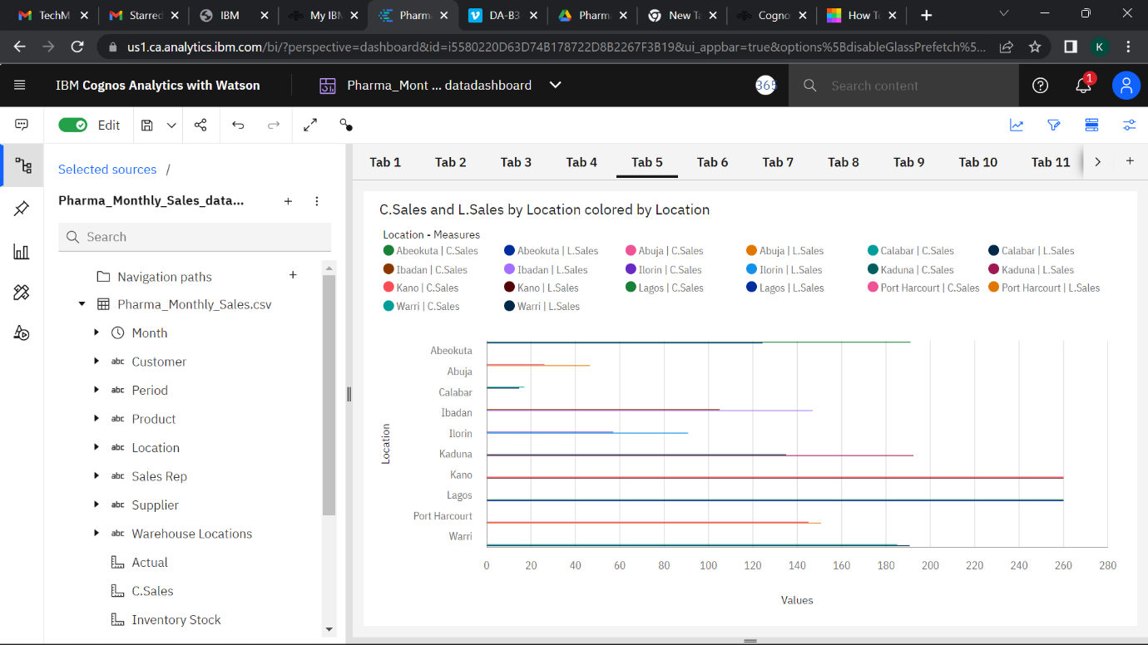

**SALES BY SALES REPRESENTATIVE**

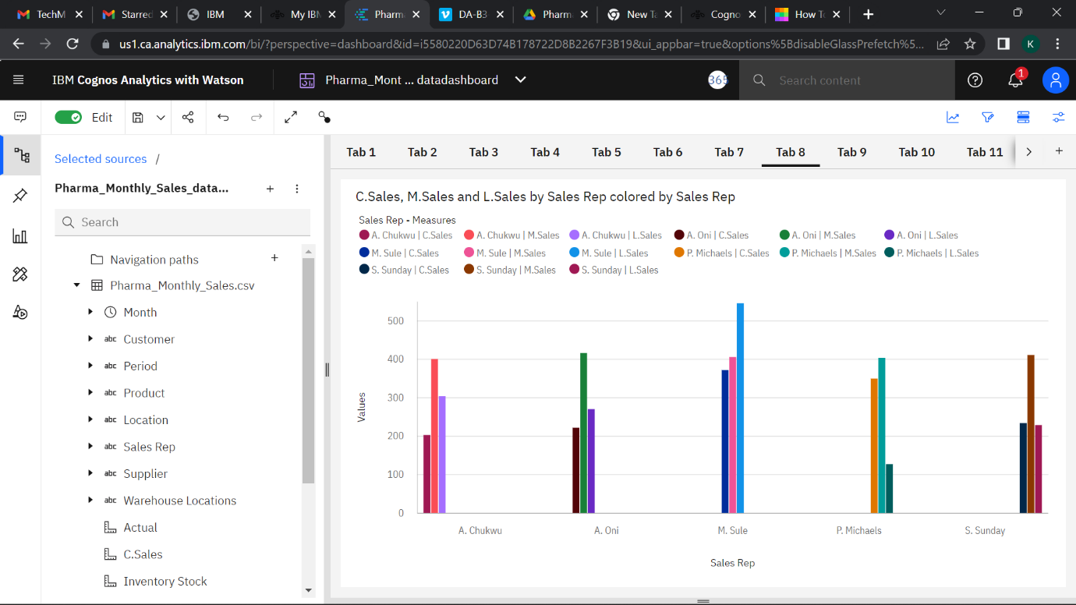

**RECEIVED INVENTORY FROM SUPPLIER**

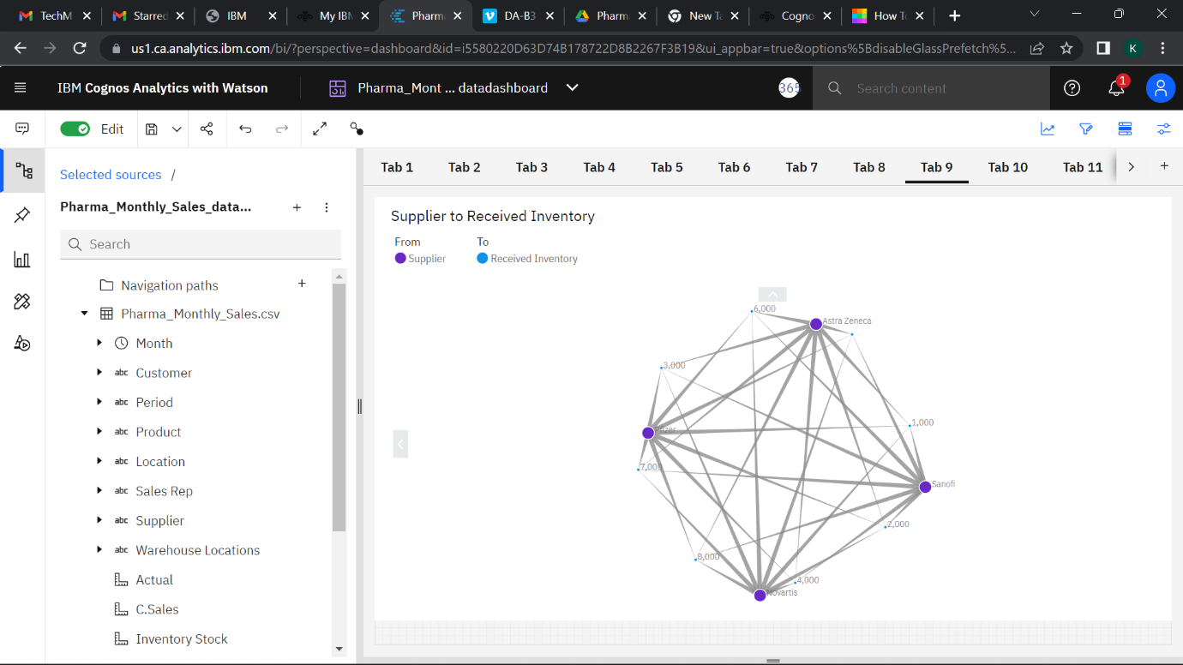

**INVENTORY STOCK FOR WAREHOUSE LOCATIONS**

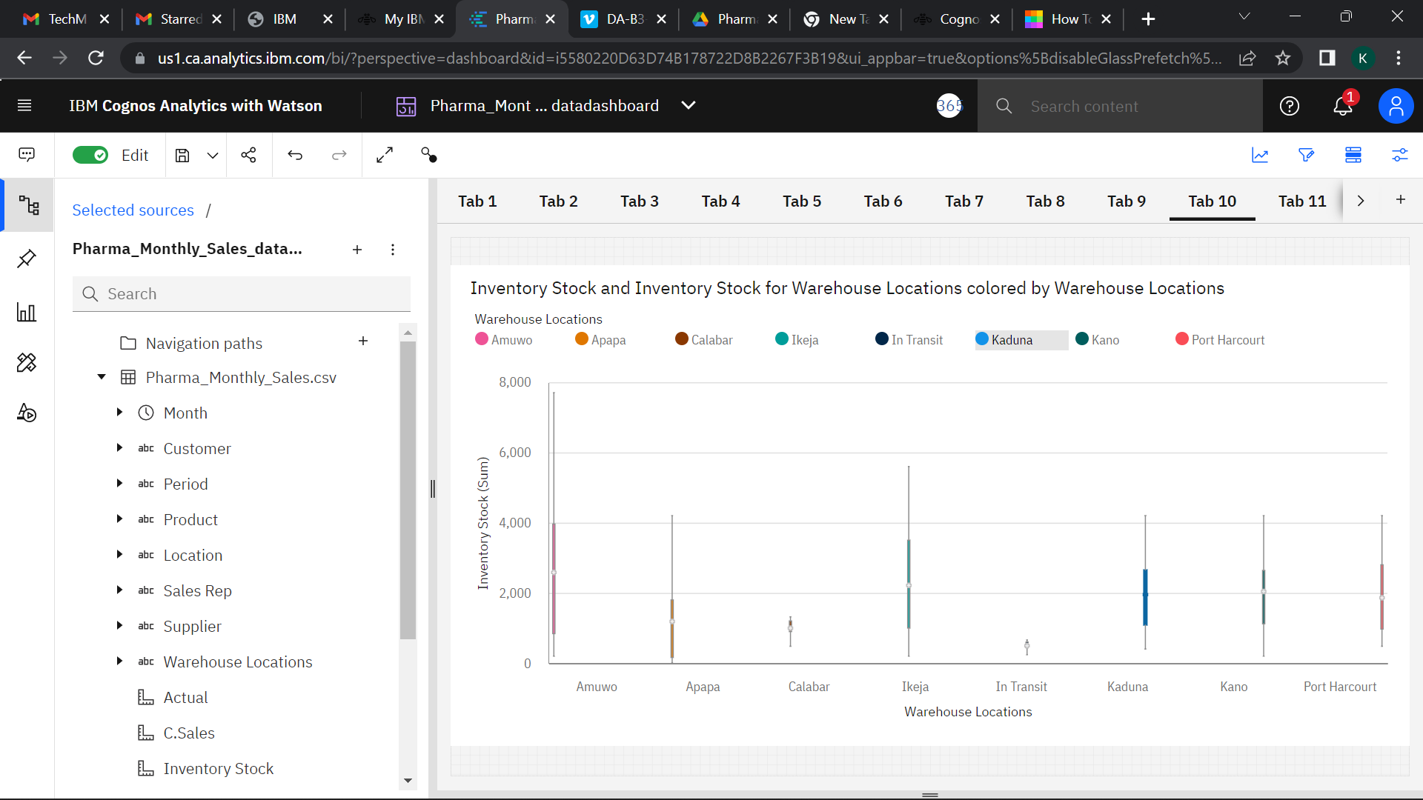

**ACTUAL AND RECEIVED INVENTORY BY MONTH** 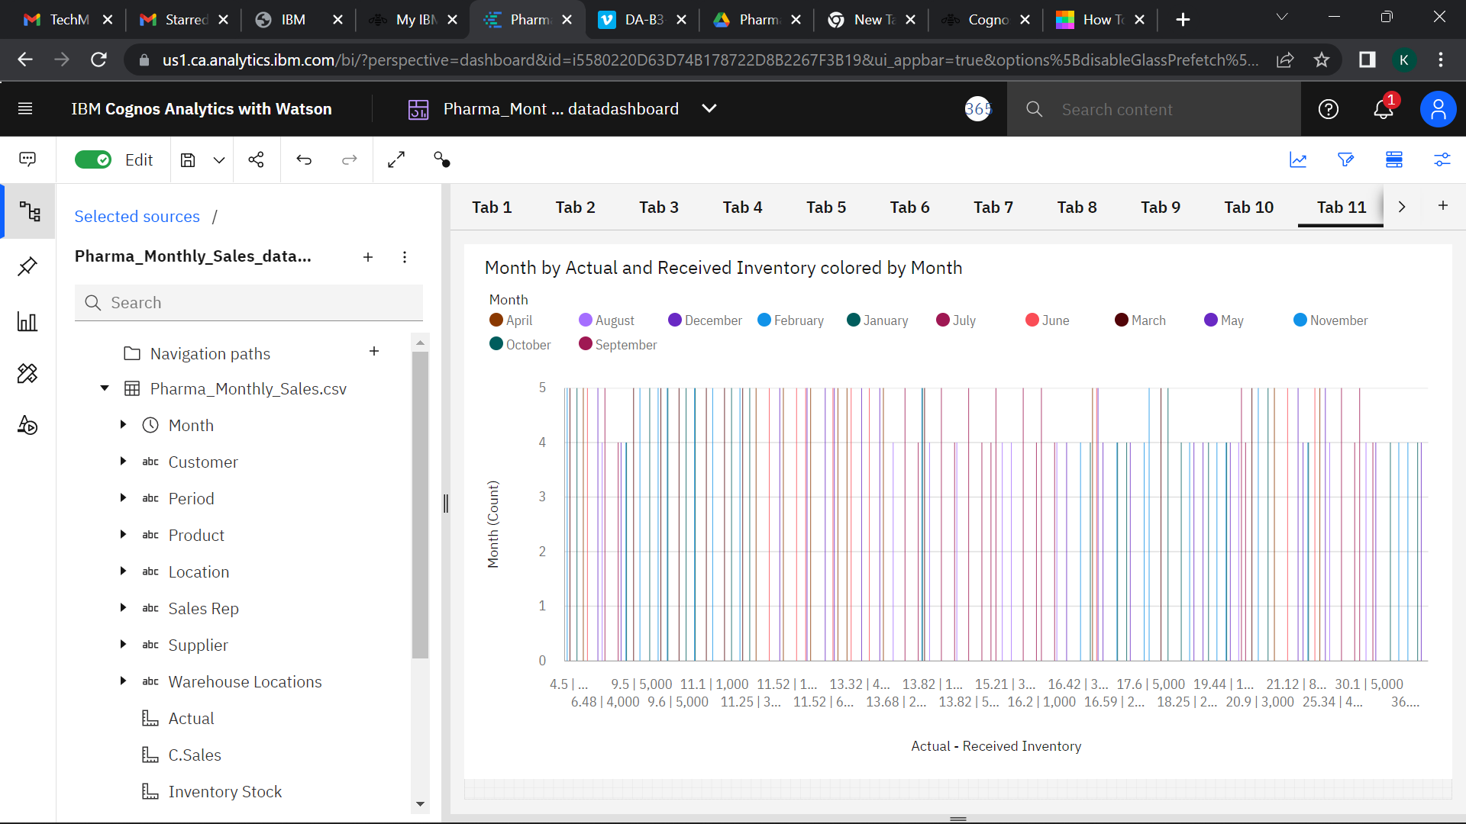

**SALES TREND**

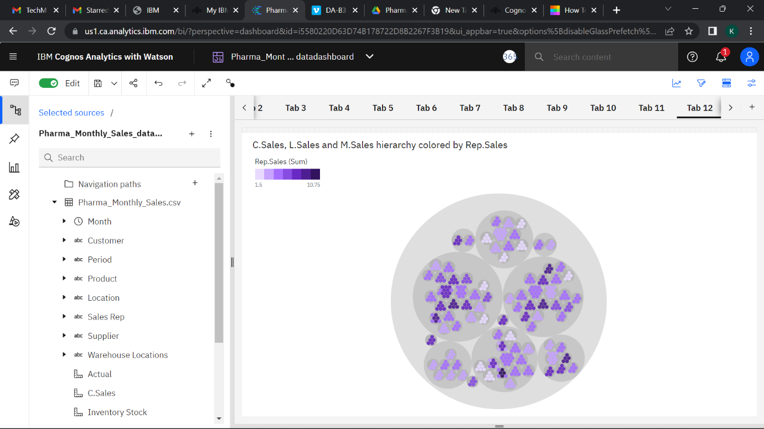

**MONTHLY SALES**

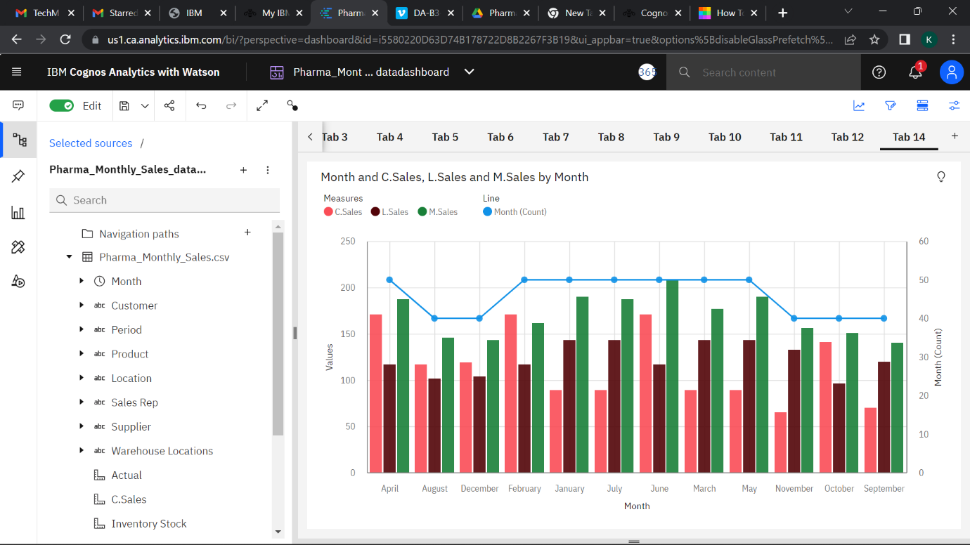

**IBM EXPLORE LINK**

<https://us1.ca.analytics.ibm.com/bi/?perspective=explore&pathRef=.my_folders%2FPharma_Monthly_Sales_dataexplore&subView=model0000018373fb0970_00000001>

**IBM DASHBOARD LINK**

<https://us1.ca.analytics.ibm.com/bi/?perspective=dashboard&pathRef=.my_folders%2FPharma_Monthly_Sales_datadashboard&action=view&mode=dashboard&subView=model00000183742b8da0_00000000>